COMP6009 Assignment Part A: A Danger-Aware A* Agent for CoinTex
Colombo-group-08
Pavithra Solomons (24079123), Ravindu Chandrasekara (24100201), Rashmika Dilshan (20543909)
Contents
- Part 1: Understanding the greedy program
- Part 2: Our proposed algorithm
- Part 3: Performance comparison
- Part 4: Future work
- Conclusion
- Appendix A: Files and how to reproduce the results
- Appendix B: Results for every level
- References
DRAFT: the greedy results below cover only 59 of 120 episodes. Every number will be rebuilt from the final data.
All results in Part 3 come from 299 episodes played in the real CoinTex game on one of our laptops: three agents, 24 levels and 5 runs per level, logged by main_partA.py to partA_results.csv. We also wrote a headless copy of the game rules, sim_partA.py, to test ideas quickly. We used it only while developing the agent and to draw Figure 3.

Part 1: Understanding the greedy program

1.1 How main_work_greedy.py plays the game
The program is the CoinTex game written in Kivy, with an agent added on top. When a level opens, screen_on_enter starts the monster and fire animations and then starts a thread called CollectCoinThread. That thread is the agent. It plays by calling start_char_animation, which is the same method a mouse click uses, so the agent is really just clicking on the screen for us.
The thread follows the loop in Figure 1. It first moves the character to a fixed point, (0.1, 0.1). It then reads where every coin, monster and fire is, throws away any coin that is within 0.3 of a monster or fire, and builds a table of Manhattan distances between the start point and the remaining coins. findMinRoute turns that table into a visiting order by always going to the nearest unvisited coin next. This is the nearest-neighbour heuristic for the travelling salesman problem, and it is the greedy part of the program. The character then jumps to each coin in that order, one jump every 0.4 seconds. When the route is finished the thread reads the positions again and repeats until no coins are left.
This is the same idea as greedy best-first search from Lecture 3 (Curtin University, 2025c). It always takes the option that looks closest, using only the forward cost (the distance still to go), and never counts what it costs to get there. Lecture 3 warns that this “takes you straight to the (wrong) goal”. In CoinTex the hidden cost is danger: a coin can be close and still be the wrong choice because a monster or fire is in the way.
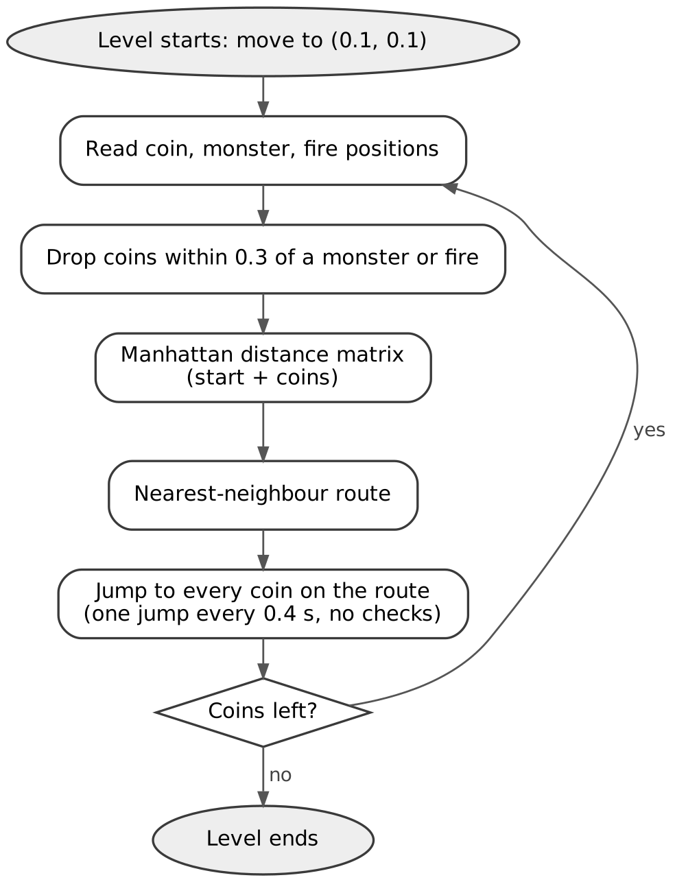
Figure 1: How the original greedy agent works

1.2 What goes wrong
Reading the code and watching it play, we found the problems in the table below. The first three are why it dies on the harder levels. The others are bugs that affect the results or make them hard to measure.
# | What we found | Effect on play
G1 | Monsters and fires are only used to skip coins at planning time | The jump from one coin to the next can go straight through a monster or a fire
G2 | The whole route is planned from one snapshot | Monsters keep moving while the agent works through the route at 0.4 s per coin, so the plan is out of date after the first few jumps
G3 | start_pos is always (0.1, 0.1) | Every new plan is measured from the corner, not from where the character actually is, so the visiting order is wrong after the first pass
G4 | check_coin deletes items from the list it is looping over, inside a monster × fire double loop, and a bare except hides the errors | The wrong coins can be dropped, and some coins near hazards are not dropped at all
G5 | Distances are Manhattan distances | The character moves in straight lines, so the distance measure does not match how it moves
G6 | The thread never stops after the character dies | On the next level two agents drive the same character. When all coins are collected the thread also crashes with a TypeError
G7 | time.perf_counter() is called but its result is thrown away | Nothing is timed or logged, so there was no way to measure the agent

1.3 Two facts about the game that shaped our design
Every jump takes exactly 0.25 seconds (char_anim_duration), however far it goes. A jump across the whole screen takes the same time as a jump to the next coin. This means the time to clear a level depends on how many jumps the agent makes, not on how far the character travels. The greedy agent works hard to shorten the distance, which saves no time at all in this game. Distance only matters because a long jump crosses more of the screen and is more likely to pass through something dangerous.
The second fact is how damage works. The game takes one life point away for every frame that the character touches a monster or fire, and the character dies after 20 to 35 such frames depending on the level. At 60 frames per second that is roughly a third to half a second of contact. A quick brush past a hazard is survivable, but standing next to one or crossing its path slowly is not. So the agent needs to know when it will be near a hazard as well as where.
We read the sizes from cointex.kv. The character and monsters are 0.15 of the screen wide and fires are 0.03. A monster hits when the centres are within 0.075 of each other on both axes. A fire hits, and a coin is collected, when the centres are within 0.05.

1.4 The task environment
Lecture 1 describes an agent’s task with PEAS (Curtin University, 2025a). For CoinTex it looks like this:
PEAS | CoinTex
Performance measure | Collect every coin, as quickly as possible, without losing all of the life bar
Environment | One level: coins in random places, monsters walking to random points, fires bouncing on fixed paths
Actuators | One action: jump to a point on the screen (start_char_animation), which takes 0.25 s
Sensors | The positions of the character, coins, monsters and fires, read from the game widgets
Using the environment types from the same lecture, the game is fully observable, because the agent can read every position. It is not deterministic, because monsters choose random targets and speeds. It is dynamic, because the hazards keep moving while the agent thinks, and it is continuous in both space and time. It is also not a single-agent world, but the monsters are not trying to beat the agent either; they move at random. The greedy program behaves like a goal-based agent that plans once and then stops sensing until its route is done. Our agent keeps a little state (the previous snapshot, used to estimate how fast each hazard is moving) and senses again before every jump.

Part 2: Our proposed algorithm

2.1 Why we chose A* search
Collecting coins in CoinTex looks like a travelling salesman problem, and that is how the greedy program treats it. We think it is closer to a path finding problem with moving obstacles. A coin that is 0.2 away but sits behind a monster is not really close, because reaching it can end the level. That is why the monster and fire positions have to be part of the decision, even though the goal is only to collect coins.
A* fixes exactly the weakness of greedy search that Lecture 3 points out. It ranks each point by f(n) = g(n) + h(n), where g(n) is the actual cost of the path so far (the backward cost) and h(n) is a guess of the cost still to go (the forward cost). It expands the point with the lowest f(n) first and stops when a goal is taken off the fringe, not when it is first added (Hart, Nilsson and Raphael, 1968; Russell and Norvig, 2021). If the guess is admissible, meaning it never overestimates the true remaining cost, the path A* returns is the cheapest one. If we make danger part of the step cost g, the cheapest path becomes the one that best balances distance and risk. A* is also fast enough to run again before every jump, so the plan never goes stale.
Following Lecture 2 (Curtin University, 2025b), we wrote the agent’s decision as a search problem:
- State space: the cells of a 40 × 40 grid laid over the play area.
- Successor function: move to any of the 8 neighbouring cells. The cost of a move is its length × (1 + 8 × danger), where danger comes from the predicted monster and fire positions (section 2.3).
- Start state: the cell the character is in now.
- Goal test: the cell contains a coin.
The wrap-up lecture (Curtin University, 2026) suggests asking four questions about any search: what is the space, the objective, the guidance and the budget. Our answers are below.
Question | Our answer
Space | 1,600 grid cells, 8 moves from each
Objective | The cheapest path to any coin, where cost is distance weighted by danger
Guidance | h(n) = straight-line distance to the nearest coin
Budget | One decision per 0.25 s jump. On our laptop a decision took 6.7 ms on average
Our heuristic comes from a relaxed problem, which is how Lecture 3 suggests building admissible heuristics. If there were no monsters or fires and the character could move in any direction, the cheapest way to a coin would be a straight line. The real problem can only cost the same or more, so the guess never overestimates. It is also consistent: one move can never lower h by more than the length of that move, and every move costs at least its length. Lecture 3 notes that consistency is what A* needs when it keeps a closed set of visited cells (graph search), as ours does.

2.2 Flow of the algorithm
Figure 2 shows one decision of our agent. The agent repeats this loop every 0.25 seconds, once per jump, until the coins run out or the character dies.
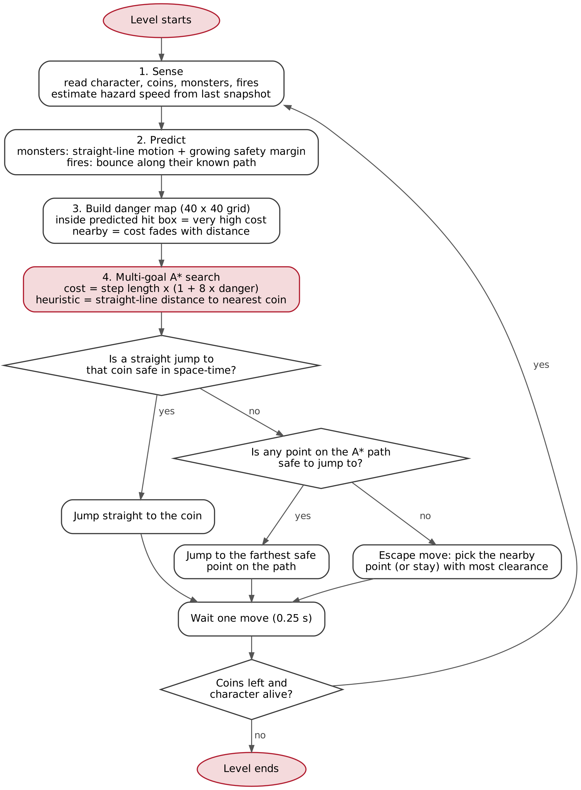
Figure 2: Flow of the proposed danger-aware A* agent (one loop per jump)
The same loop as pseudo-code:
every 0.25 s, until no coins are left or the character is dead:
world = snapshot() # character, coins, monsters, fires
speeds = change in each hazard position since last snapshot
danger = 40 x 40 grid of zeros
for t in (0, 0.15, 0.30, 0.45, 0.60) seconds ahead:
predict every monster and fire at time t
cell inside hit box + margin(t) -> danger = 40 x weight(t)
any other cell -> danger = exp(-clearance/sigma) x weight(t)
path, coin = A*(start = character's cell,
goals = every coin's cell,
step cost = length x (1 + 8 x danger),
guess = straight-line distance to nearest coin)
if the straight jump to that coin is safe in space-time:
target = coin
elif some point on the path is safe to jump to:
target = farthest safe point on the path
else:
target = nearby point (or stay) with the most clearance
move(target)

2.3 How monsters and fires are included
Before planning, the agent predicts where each hazard will be over the next 0.6 seconds. Monsters walk in straight lines to random points and change direction at random, so the agent assumes they keep their current speed and direction and adds a safety margin that grows the further ahead it looks (0.035 now, plus 0.30 for every second ahead). Fires are easier. Each fire bounces back and forth between two fixed points written in cointex.kv, so the agent works out where the fire is along that line and which way it is moving, then predicts it forward, bouncing at the ends.
These predictions are turned into a danger map, a 40 × 40 grid over the play area (each cell is 2.5% of the screen). A cell that falls inside a predicted hit box, plus the margin, gets a very high danger value. Cells outside it get a danger value that fades quickly with distance. Predictions further ahead count a little less, because they are less certain. Figure 3 shows a real example from level 22.
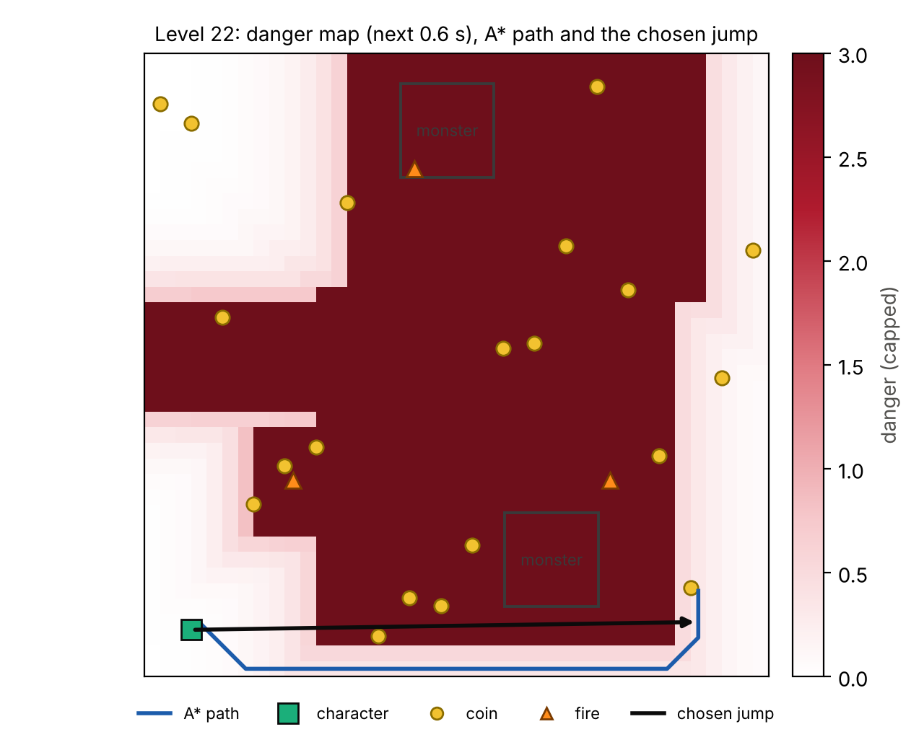
Figure 3: Level 22 in the simulator. Dark red cells are where a monster or fire is predicted to be at some point in the next 0.6 s. The blue line is the A* path to the cheapest coin. The black arrow is the jump the agent chose: it cuts the corner because the hazards will have moved away by the time the character passes.

2.4 The search and the safe jump
A* runs on the danger map with eight neighbours per cell. A step through a safe cell costs its length, and a step through a dangerous cell costs a lot more. All coins are goals at once, and the search stops when the first coin cell is taken off the fringe. Because the heuristic is consistent, that is the coin with the cheapest path once danger is counted, so A* also decides which coin to go for. The greedy program makes that choice on distance alone.
Following the A* path one cell at a time would be very slow, because every jump costs 0.25 seconds. Instead the agent looks for the longest straight jump it can make along the path. It first checks whether it can jump straight to the coin. If not, it tries the points on the path from the far end backwards and takes the first one that is safe. This shortcut idea is similar to any-angle path planning such as Theta* (Daniel et al., 2010).
The safety check is where time comes in. A jump of length L takes 0.25 seconds, so the agent knows when the character will be at each point along the line. It checks the line every 0.02 of the screen and compares each point with where every hazard will be at that moment, not where it is now. It also checks that the landing point stays safe for a short time afterwards. In Figure 3 the jump crosses cells that look dangerous on the map, but the check shows the hazards will not be there when the character passes. If nothing on the path is safe, for example when a fast monster is very close, the agent tries 64 nearby points and staying still, and picks the one that keeps it furthest from danger.

2.5 What is new compared with the greedy agent
 | Original greedy agent | Our A* agent
How a coin is chosen | Nearest by Manhattan distance; the whole route is fixed in advance | Cheapest path once danger is counted; chosen again before every jump
Monsters and fires | Only used to skip coins within 0.3 when planning | Predicted 0.6 s ahead and built into the cost of every cell
How it moves | Straight jumps to each coin with no checks | Jumps only along lines that are clear at the time the character passes
How often it re-plans | After the whole route | Every 0.25 s
Where planning starts | Always (0.1, 0.1) | The character’s real position
When in danger | No reaction | Escape move to the point with the most clearance
Search method | Nearest-neighbour heuristic | Multi-goal A* with a guess that never overestimates

2.6 How we built and tested it
To make the comparison fair, all three agents play exactly the same game. We copied the game code from main_work_greedy.py into main_partA.py and only added a few lines that tell our test harness when a level starts, when all coins are collected and when the character dies. Levels, speeds and collision rules are unchanged. Each agent sits in its own file and talks to the game through the same three calls: read the positions, move to a point, and wait. All moves go through the game’s own start_char_animation, called on Kivy’s main thread, so no agent has an advantage in how it moves.
The original greedy logic (create_matrix, check_coin, findMinRoute and the route loop) is copied unchanged into agent_greedy.py. The only differences are that it reads positions through the harness and that it stops cleanly when the level ends instead of crashing. We tuned the A* settings (the danger weight of 8, the margins and the look-ahead times) using a small headless copy of the game rules, sim_partA.py, because it can play hundreds of levels in a few minutes. None of the results in Part 3 come from that simulator.

Part 3: Performance comparison

3.1 How we ran the comparison
We compared three agents in the same harness:
- Greedy: the original logic from main_work_greedy.py, unchanged.
- Genetic algorithm (GA): the GA agent that comes with CoinTex in PlayerGA/TutorialProject/main.py. It uses a population of 1000 two-gene solutions (a target point), scores each point by closeness to the first coin in the list with a penalty for being within 0.3 of a monster or fire, and moves the character whenever the best score changes. It was written for an older PyGAD and does not start on PyGAD 3.9.2, so we made four porting changes and nothing else: a three-argument fitness function, on_generation instead of callback_generation, a sleep instead of delay_after_gen, and keep_elitism=0, keep_parents=0. The last one matters. PyGAD 3 reuses old fitness values for elite and parent solutions, and in a moving game those values go stale, the best score stops changing and the character freezes. Turning the cache off gives the behaviour the tutorial was written for.
- A*: our danger-aware agent from Part 2.
Each agent played all 24 levels 5 times, which is 120 episodes per agent. The game places the coins at random every time, so every run is a different layout. An episode ends when all coins are collected, when the character dies, or after 60 seconds.
We measured:
- Success rate: the percentage of episodes where every coin was collected without dying. We also count a level as completed when the agent won at least 3 of its 5 runs.
- Time to collect all coins: from the moment the level starts to the last coin, for successful runs only.
- Life left: the share of the life bar left when the episode ended.
- Risk-adjusted collection rate (RACR): our proposed extra metric, explained in section 3.4.
One note on the data. In our first batch two game windows were open by accident for the first three greedy levels, so those games competed for the computer, and the greedy batch stopped after level 15. We removed those rows, kept the original file as partA_results_raw_run1.csv, and re-ran the missing greedy episodes on their own. We also changed the runner so that a second window cannot write to the same results file.

3.2 Overall results
Measure | Greedy | GA | A* (ours)
Episodes won | 52 / 59 | 99 / 120 | 120 / 120
Success rate (95% interval) | 88.1% (77-94) | 82.5% (75-88) | 100.0% (97-100)
Levels completed (3+ wins of 5) | 12 / 24 | 21 / 24 | 24 / 24
Levels won in all 5 runs | 7 / 24 | 12 / 24 | 24 / 24
Mean time, successful runs (s) | 5.34 | 11.54 | 4.60
Mean time on the 12 levels all three won at least once (s) | 5.39 | 10.85 | 4.41
Jumps per successful run | 13.9 | 32.6 | 16.9
Life left (%) | 64.6 | 57.2 | 99.7
Deaths / timeouts | 7 / 0 | 21 / 0 | 0 / 0
Hit frames per episode | 9.3 | 12.3 | 0.1
RACR (coins per second × life left) | 1.60 | 0.81 | 3.10
Planning time per decision (ms) | - | - | 6.7 (max 20.2)
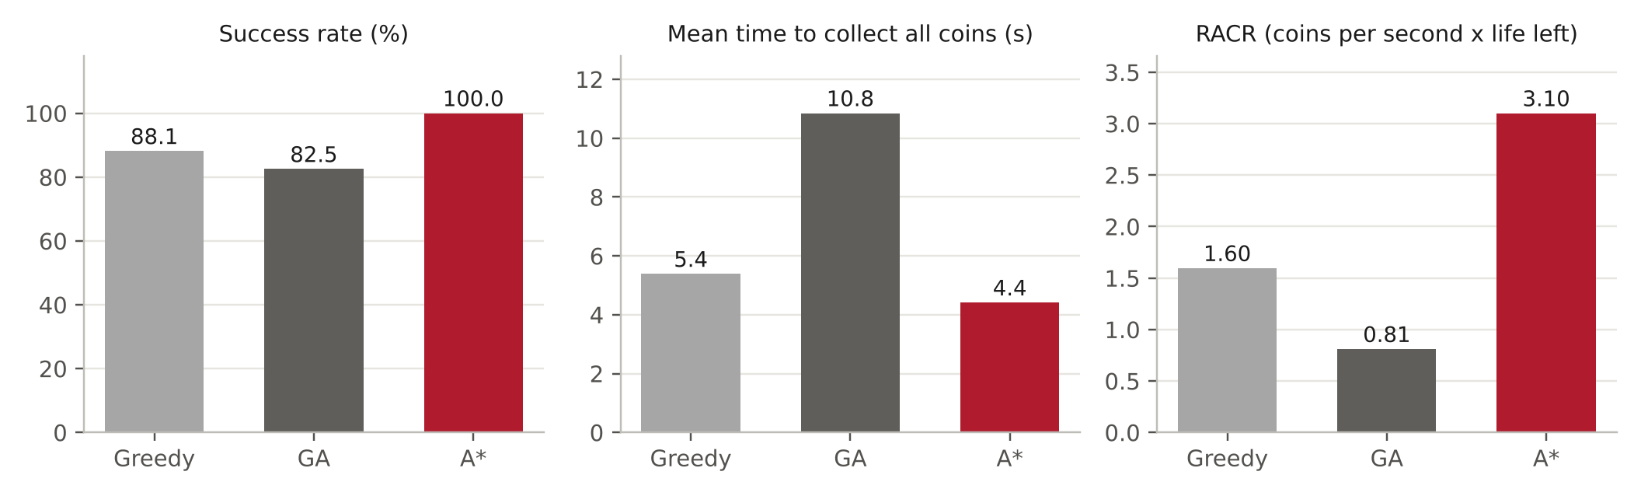
Figure 4: Overall results. The middle panel uses only the 12 levels that all three agents won at least once, so no agent is helped by skipping hard levels.
Our A* agent won every one of its 120 runs and completed all 24 levels. The GA won 99 of 120 runs (82.5%) and the greedy agent won 52 of 59 (88.1%). The 95% intervals in the table show how much these rates could move with more runs. The A* interval does not overlap with either of the others, so the gap is larger than run-to-run luck.
A* was also the safest. It finished with 99.7% of its life on average and touched a hazard for 0.1 frames per episode, against 9.3 frames for greedy and 12.3 for the GA.
Comparing time is harder, because an agent that only wins the easy levels looks fast. So for the time comparison we used only the 12 levels that all three agents won at least once. On those levels A* took 4.41 s on average, against 5.39 s for greedy and 10.85 s for the GA. Level by level, A* was faster than greedy on 10 of the 12 levels and faster than the GA on 12 of them.

3.3 Results level by level
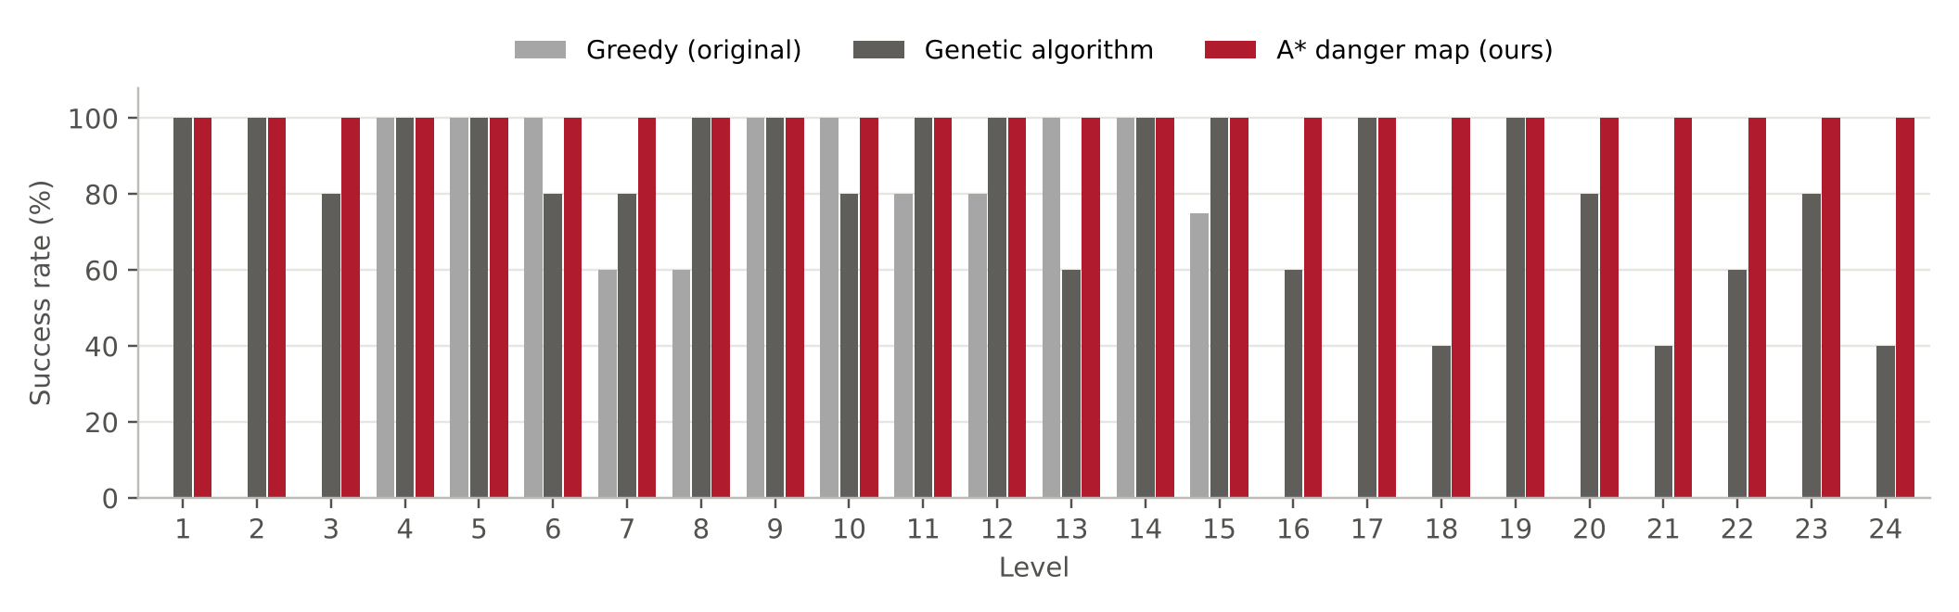
Figure 5: Success rate on each level (5 runs per agent per level)
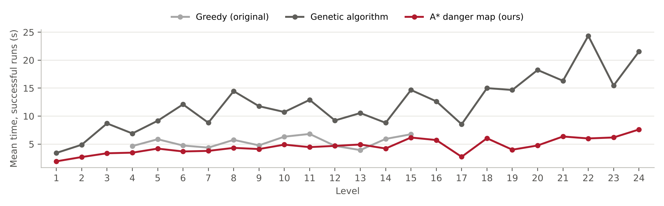
Figure 6: Mean time to collect all coins on each level, successful runs only
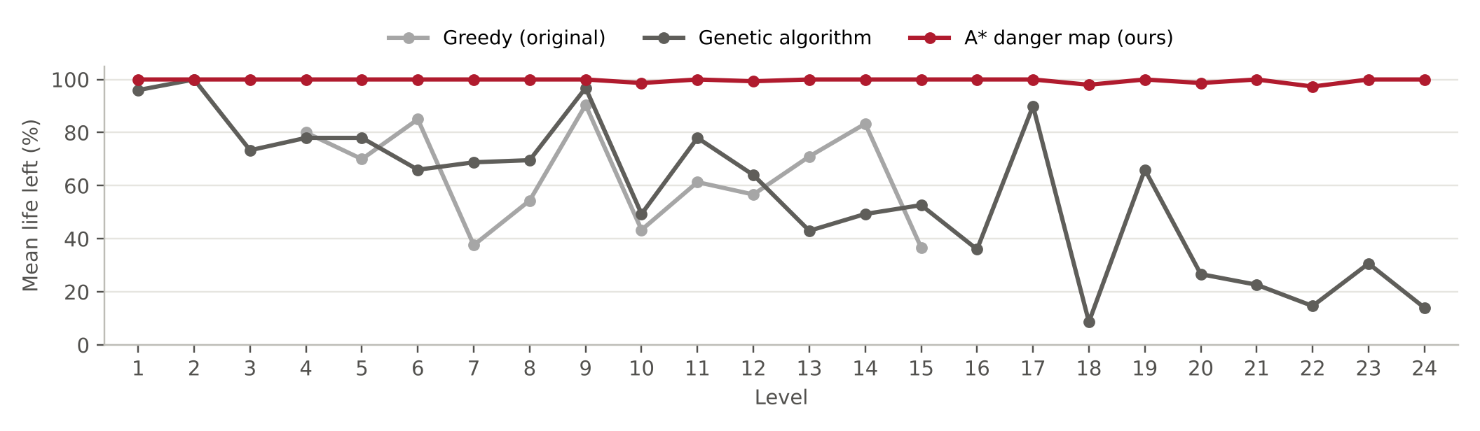
Figure 7: Mean life left at the end of each episode
Greedy lost 7 runs, spread over levels 7, 8, 11, 12 and 15. Its worst levels were level 7 (3/5 wins, 3 monsters); level 8 (3/5 wins, 2 monsters); level 15 (3/5 wins, 2 monsters and 3 fires). Every one of these losses was a death, not a timeout. That fits problem G1 from Part 1: the straight jumps between coins are never checked, so on these levels they keep crossing a monster or a fire. The GA lost 21 runs, on levels 3, 6, 7, 10, 13, 16, 18, 20, 21, 22, 23 and 24. It struggled most on level 18 (2/5, 3 monsters and 4 fires); level 21 (2/5, 2 monsters and 4 fires); level 24 (2/5, 3 monsters and 2 fires); level 13 (3/5, 2 monsters and 2 fires). The GA aims only at the first coin in the list and judges a point only by where it ends up, so the path to that point can run straight through a hazard. A* won every run on every level.
In Figure 6 the GA’s time grows with the number of coins on a level (rank correlation 0.88). It needed 32.6 jumps per successful run, 1.9 times as many as A* (16.9), because it always heads for the first coin in the list even when others are closer, and it only moves when its best score changes. In Figure 7 the A* line stays close to 100% life on every level, while greedy and the GA lose more life on the later levels.

3.4 Our extra metric: risk-adjusted collection rate
Success rate and time each tell only part of the story. An agent that wins with 5% life left counts the same as one that is never touched, and the time measure ignores failed runs completely. We propose one number that combines speed, progress and safety:
RACR = (coins collected ÷ time in seconds) × fraction of life left
It is the rate of coin collection, scaled down by how much damage the agent took. A run that collects every coin quickly without being hit scores high. A fast but reckless run scores low because its life is low, and a run that dies scores zero because its life is zero, even if it collected most coins before dying. Failed runs therefore still count, which the time measure cannot do.
A* scored 3.10, which is 1.9 times the greedy agent (1.60) and 3.8 times the GA (0.81). Greedy beats the GA on both success rate and RACR. RACR widens the gap because the GA is slow even when it wins.

3.5 Why the A* agent does better
Safety comes from the space-time check. The agent only makes a jump if every point on it is clear at the moment the character passes, and it re-plans from its real position every 0.25 s with fresh hazard positions. That is why it touched a hazard for 0.1 frames per episode. The greedy agent plans once per route and then jumps blind, and the GA scores only the landing point, so both walk through monsters and fires.
Speed comes from two things. The first is how often each agent moves. The original greedy code waits 0.4 s after every jump, while our agent moves as soon as the 0.25 s animation finishes. On successful runs greedy spent 0.38 s per jump and A* spent 0.27 s. We kept the greedy timing exactly as given, because the brief asks us to compare against the original program, but part of the time saving comes from this faster rhythm and not from the search itself. The second is the number of jumps. A* made 16.9 jumps per win, a little more than greedy’s 13.9, because it sometimes detours or steps aside to stay safe, but far fewer than the GA’s 32.6. So the time saving comes from moving without pauses and rarely having to back off, while still keeping clear of the hazards.
The method is also cheap. A decision took 6.7 ms on average and 20.2 ms at most on our laptop, which is well inside the 250 ms budget of one jump. The GA, by comparison, scores 1000 candidate points in Python every generation.

3.6 Limitations of our comparison
All runs were on one laptop, so the times would be different on another computer. This affects the GA most, because it scores 1000 solutions in Python between moves. Five runs per level is enough to see the overall pattern, but a single level’s success rate moves in steps of 20%, so small differences between levels should not be over-read. We tuned the A* settings in our simulator, which copies the game rules but not every detail of how Kivy runs. The GA we compared against is the tutorial GA with only the porting changes above, not a GA tuned for this game. Finally, part of the time saving comes from how often each agent moves, which we discuss in section 3.5.

Part 4: Future work
These are ideas we did not implement, with our reasons for thinking they would help.

4.1 A hybrid of the genetic algorithm and A*
Our A* agent always goes for the coin with the cheapest safe path from where it is now. That is still a short-sighted choice about the order of coins. Sometimes it collects a nearby coin and leaves one coin stranded in a far corner, and the final jumps to fetch it cost extra time. The tutorial GA has the opposite strengths and weaknesses. It explores many candidate points, but it scores only the end point, ignores the path to it, and needs around 0.25 s per generation to make a move.
A hybrid would let each method do the part it is good at. The GA would choose the order of the remaining coins, and A* would handle the safe legs between them:
- Chromosome: a permutation of the remaining coins (the visiting order), using order-based crossover and swap or inversion mutation.
- Fitness: walk through the order, run A* on the current danger map from each coin to the next, and add up the path costs. Leaving a coin isolated at the end of the order then shows up as a high cost.
- Timing: the best order changes slowly, so the GA can run in the background and update the order every second or so. A* keeps re-planning the next jump every 0.25 s, which is what keeps the character safe.
We expect this to cut the number of jumps on levels with many coins (levels 21 to 24 have 18 to 25 coins) without losing safety. The cost is more computation. A* takes about 7 ms per path, so scoring one order of 20 coins would take a fraction of a second. The A* searches would need to be reused between orders, or replaced by a cheaper estimate such as straight-line distance plus a danger penalty.
A simpler hybrid would use the GA to tune our A* settings. We picked the danger weight, the margins and the look-ahead times by hand in the simulator. A GA could search these values offline, with fitness equal to the success rate and time over many simulated levels, and could even find different settings for monster-heavy and fire-heavy levels.

4.2 Other improvements
Space-time A*. Our search treats the danger map as fixed and only brings time in when it checks a jump. Adding time as a third dimension to the grid, as in cooperative path finding (Silver, 2005), would let the agent plan to wait for a monster to pass and then go, instead of only finding a way around it.
Faster re-planning. The agent searches from scratch every 0.25 s even though most of the map has not changed. D* Lite (Koenig and Likhachev, 2002) repairs the previous search instead, which would matter if we used a finer grid.
Better monster prediction with a Markov model. We assume monsters keep their current speed and direction, which is a simple version of the Markov assumption from Lecture 8 (Curtin University, 2025e): the next position depends only on the current state. Lecture 8 uses the same question we faced (“Where is the monster? Where might it move?”). A proper Markov model of monster movement, with a belief over where each monster is heading that is updated every frame (HMM-style filtering), would give a probability for each cell instead of one predicted point. The danger map could then use the probability of a hit, and the safety margins could shrink.
Expectimax instead of a fixed margin. The monsters are not adversaries; they move at random. Lecture 6 (Curtin University, 2025d) explains that in this case the agent should plan for the average outcome (expectimax), not the worst case (minimax). A short depth-limited expectimax over the next two or three jumps, with chance nodes for where each monster might go, would let the agent take a slightly risky shortcut when the expected payoff is high, instead of always keeping the same margin.

Conclusion
The greedy agent in main_work_greedy.py picks coins by distance and ignores monsters and fires once it starts moving, which is why it dies on the harder levels. We replaced it with a danger-aware A* agent that predicts where hazards will be, plans the cheapest safe path to a coin and only makes jumps that are clear at the moment the character passes. Over 120 episodes in the real game it won 120 of 120, against 52 for the greedy agent and 99 for the tutorial GA. On levels all three agents could win it was also the fastest, and it finished with 99.7% of its life on average. Planning takes about 7 ms per decision, so the method is cheap enough to run before every jump.

Appendix A: Files and how to reproduce the results
All files are in CoinTex/PlayerGA/TutorialProject.
File | Purpose
main_work_greedy.py | Original greedy program from Blackboard, unchanged
agent_greedy.py | The same greedy logic, run through the test harness
agent_ga.py | Tutorial GA from main.py, ported to PyGAD 3.9.2
agent_astar.py | Our danger-aware A* agent
partA_common.py | Shared snapshot type and the read / move / wait interface
main_partA.py | The game plus the harness: automatic play, timing, results log
sim_partA.py | Headless copy of the game rules, used for development only
analyse_partA.py | Summary tables and charts from the results file
run_partA_experiments.bat | Runs all three agents on all levels, then the analysis
partA_results.csv | One row per episode (the data behind Part 3)
partA_results_raw_run1.csv | First batch before the duplicated greedy rows were removed
Software: Windows, Python 3.12.10, Kivy 2.3.1, PyGAD 3.9.2, NumPy 2.5.4.
To run every experiment, double-click run_partA_experiments.bat. To run one agent from a Command Prompt in TutorialProject:
..\venv\Scripts\activate
set AGENT=astar
set LEVELS=1-24
set RUNS=5
python main_partA.py
python analyse_partA.py partA_results.csv
AGENT can be greedy, ga or astar. Episodes already in the results file are skipped, so an interrupted batch can be started again.

Appendix B: Results for every level
Wins out of 5 runs, and mean time in seconds for the successful runs.
Level | Coins | Monsters | Fires | Greedy wins | Greedy time | GA wins | GA time | A* wins | A* time
1 | 5 | 1 | 0 | n/a | - | 5/5 | 3.42 | 5/5 | 1.92
2 | 8 | 1 | 0 | n/a | - | 5/5 | 4.89 | 5/5 | 2.69
3 | 12 | 1 | 0 | n/a | - | 4/5 | 8.70 | 5/5 | 3.36
4 | 10 | 1 | 1 | 5/5 | 4.65 | 5/5 | 6.90 | 5/5 | 3.47
5 | 15 | 1 | 2 | 5/5 | 5.87 | 5/5 | 9.17 | 5/5 | 4.20
6 | 12 | 1 | 3 | 5/5 | 4.75 | 4/5 | 12.10 | 5/5 | 3.69
7 | 10 | 3 | 0 | 3/5 | 4.37 | 4/5 | 8.82 | 5/5 | 3.79
8 | 15 | 2 | 0 | 3/5 | 5.76 | 5/5 | 14.47 | 5/5 | 4.33
9 | 12 | 2 | 0 | 5/5 | 4.78 | 5/5 | 11.78 | 5/5 | 4.12
10 | 14 | 3 | 0 | 5/5 | 6.33 | 4/5 | 10.74 | 5/5 | 4.90
11 | 15 | 2 | 1 | 4/5 | 6.82 | 5/5 | 12.91 | 5/5 | 4.46
12 | 12 | 2 | 1 | 4/5 | 4.68 | 5/5 | 9.23 | 5/5 | 4.68
13 | 10 | 2 | 2 | 5/5 | 3.93 | 3/5 | 10.55 | 5/5 | 4.93
14 | 15 | 0 | 6 | 5/5 | 5.93 | 5/5 | 8.81 | 5/5 | 4.21
15 | 16 | 2 | 3 | 3/5 | 6.76 | 5/5 | 14.68 | 5/5 | 6.18
16 | 15 | 3 | 2 | n/a | - | 3/5 | 12.65 | 5/5 | 5.73
17 | 10 | 0 | 4 | n/a | - | 5/5 | 8.55 | 5/5 | 2.73
18 | 15 | 3 | 4 | n/a | - | 2/5 | 15.01 | 5/5 | 6.05
19 | 12 | 0 | 6 | n/a | - | 5/5 | 14.67 | 5/5 | 4.00
20 | 15 | 0 | 8 | n/a | - | 4/5 | 18.25 | 5/5 | 4.75
21 | 18 | 2 | 4 | n/a | - | 2/5 | 16.32 | 5/5 | 6.36
22 | 20 | 2 | 4 | n/a | - | 3/5 | 24.36 | 5/5 | 6.01
23 | 25 | 2 | 2 | n/a | - | 4/5 | 15.47 | 5/5 | 6.19
24 | 20 | 3 | 2 | n/a | - | 2/5 | 21.54 | 5/5 | 7.61

References
Curtin University (2025a) ‘Lecture 01: Intelligent agent’, COMP6009 Search and Logic Approaches to Machine Learning [Lecture slides]. Perth: Curtin University.
Curtin University (2025b) ‘Lecture 02: Uninformed search’, COMP6009 Search and Logic Approaches to Machine Learning [Lecture slides]. Perth: Curtin University.
Curtin University (2025c) ‘Lecture 03: Informed search’, COMP6009 Search and Logic Approaches to Machine Learning [Lecture slides]. Perth: Curtin University.
Curtin University (2025d) ‘Lecture 06: Expectimax search and utility’, COMP6009 Search and Logic Approaches to Machine Learning [Lecture slides]. Perth: Curtin University.
Curtin University (2025e) ‘Lecture 08: Markov models and HMMs’, COMP6009 Search and Logic Approaches to Machine Learning [Lecture slides]. Perth: Curtin University.
Curtin University (2026) ‘COMP6009 Tutorial 7-8 and unit summary’, COMP6009 Search and Logic Approaches to Machine Learning [Lecture slides]. Perth: Curtin University.
Daniel, K., Nash, A., Koenig, S. and Felner, A. (2010) ’Theta: any-angle path planning on grids’, Journal of Artificial Intelligence Research*, 39, pp. 533-579.
Gad, A.F. (2021) ‘PyGAD: an intuitive genetic algorithm Python library’, arXiv, 2106.06158.
Gad, A.F. (2026) CoinTex [source code]. Available at: https://github.com/ahmedfgad/CoinTex (Accessed: 21 October 2026).
Hart, P.E., Nilsson, N.J. and Raphael, B. (1968) ‘A formal basis for the heuristic determination of minimum cost paths’, IEEE Transactions on Systems Science and Cybernetics, 4(2), pp. 100-107.
Koenig, S. and Likhachev, M. (2002) ‘D* Lite’, Proceedings of the Eighteenth National Conference on Artificial Intelligence (AAAI-02), pp. 476-483.
Russell, S. and Norvig, P. (2021) Artificial intelligence: a modern approach. 4th edn. Hoboken: Pearson.
Silver, D. (2005) ‘Cooperative pathfinding’, Proceedings of the First Artificial Intelligence and Interactive Digital Entertainment Conference (AIIDE), pp. 117-122.

